# **15th time’s a charm – 2022 Dodge Dynasty Champion George Hayek**

## FINALLY!

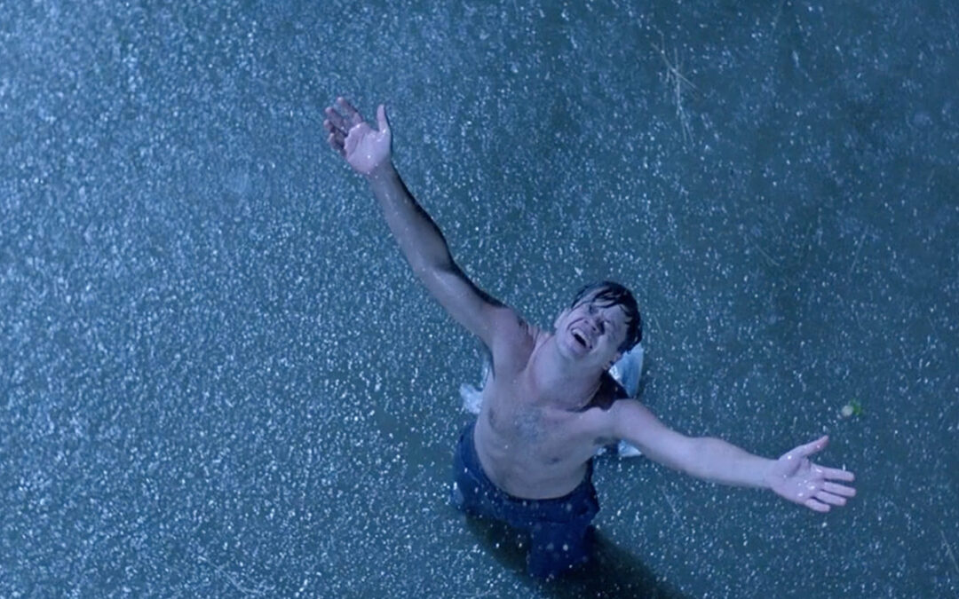

At long last, after a decade and a half of near misses and brutally unfair postseason exits, the best player in league history was finally able to grab his first championship. Congratulations to Lionel Messi for winning his first ever World Cup title!

In other news George Hawke defeated Mike Kerkel 131.2-105.5 in the semifinals and Dan Toot 104-53.8 in the finals to claim his first Dodge Dynasty title. The all-time Dynasty leader in wins, points, playoff berths & heartbreak, the Hawkeman finally doesn’t have a playoff loss to bitch about this year. George joins the ranks of his younger brother Joe, his ex-wife Jen, a guy named Shannon, and many other current and former owners to figuratively and literally have their names etched into championship history.

Runner-up Dan Toot’s magical run began when I informed him right before round one that he did in fact make the playoffs as the 5 seed (he thought there were only 4 playoff teams). It ended with me currently informing him right now that he finished runner-up. Just kidding Dan. In fairness to Dan, after dominating as the #1 seed last year this is the first time he’s ever had to concern himself with such things as wildcard berths. Amazing season Dan, especially considering the 2-7 start!

Dan avenged his #1 seed upset loss in last year’s semis to Dave Nickelsen by pulling the exact same feat in reverse this year, winning 104-69.3 over Dave’s juggernaut squad. Dave’s team picked an unfortunate time to register its first sub-triple digit score since week 7 (!), finishing as the highest 14 week pt total ever (1552.9) and 2nd highest scoring team of all time (1st - 2018 Hawke 112.8 ppg, 2nd - 2022 Dave 110.9 ppg, 3rd - 2020 Hawke 108.9 ppg, 4th - 2021 Toot 108.4 ppg). While whatever curse I had finally ended, the curse of the highest scorer continued. It’s been nine seasons and counting since the last time an overall points leader won the title that year (2013 Mr. Shannon Anderson), continuing to prove that any playoff team can and does win it all!

My dynasty rival and fourth place finisher Mike Kerkel has remarkably both cashed in the semis and finished top 3 in scoring in each of the past three years. He and I have also met in the playoffs all three times, with him ending my season in 2020 and me returning the favor the past two years. The other two playoff participants – Twitch and Meat – also added another chapter to their dynasty rivalry. Twitch edged Meat out in Week 13 to claim the Dynasty Survivor crown. A week later Meat blasted Twitch back to the stone age in their Week 14 rivalry matchup, punctuating Meat’s first playoff berth since 2016 & ending the longest playoff drought in league history.

Jason Bratten (and brother/co-manager Dan Bratten) had the unlucky honor of being the highest scoring non-playoff team for the second straight year. But Jason is all aboard the Deshaun Watson train now, discarding lower paid QB Patrick Mahomes and riding the Watson-Cooper stack into the future. Accordingly, Jason has now been added as defendant to several more Tony Buzbee lawsuits.

And though nearly every team still had a path to the playoffs entering Week 14, three of the four non-playoff teams this year (Jason, Jay, Jeremiah, and Steve) also missed the playoffs last year. Prediction for 2023: I’ll set the over/under for new playoff teams next year at 3 and take the *over*.

In 2000 Pete Carroll pushed Paul Hackett out the door, replacing him as head coach at USC. In 2022 Pete Carroll pushed Nathaniel Hackett (Paul's son) out the door, unloading franchise time-bomb Russell Wilson onto the Denver Broncos. This has nothing to do with anything.

Thank you everyone for another successful Dodge Dynasty season! I hope to see you all next year, have a wonderful 2023!

# **2022 Dodge Dynasty Awards**

**Dodge Dynasty MVP**

Winners: Derrick Henry – Meat; Justin Jefferson – Dave

Runners-up: Patrick Mahomes – George; Josh Jacobs – Jeremiah; Josh Allen – Kerkel; Davante Adams – Twitch; Austin Ekeler – Jason; Tyreek Hill – Kerkel; Christian McCaffrey – Jay

**Playoff MVP**

Winner: CeeDee Lamb – George

Runners-up: James Conner – Toot; Patrick Mahomes – George; Travis Etienne – Kerkel

**Pickup of the Year**

Winner: Jamaal Williams – Jason

Runners-up: Tyler Lockett – Toot; Justin Fields – Dave; Geno Smith – Jason; Raheem Mostert – Jason; Jeff Wilson Jr. – Meat; Tua Tagovailoa – Steve; Patriots D/ST – Dave

**Sleeper of the Year**

Playing for the team that drafted them

Winner: Tony Pollard – Dave

Runners-up: Christian Kirk – Twitch; DeAndre Hopkins – Meat; Christian Watson – Twitch; Trevor Lawrence – Dave; Kirk Cousins – Toot; Brian Robinson – Meat

**Breakout Player of the Year**

Non-Rookie

Winners: Tony Pollard – Dave; Josh Jacobs – Jeremiah

Runners-up: Rhamondre Stevenson – Steve; Joe Burrow – Meat; Jalen Hurts – Dave; Jaylen Waddle – Steve; Travis Etienne – Kerkel; Amon-Ra St. Brown – Dave; DeVonta Smith – George

**Rookie of the Year**

Winners: Kenneth Walker III – Meat

Runners-up: Dameon Pierce – Twitch; Chris Olave – Steve; Garrett Wilson – Twitch; Christian Watson – Twitch; Brian Robinson – Meat; Tyler Allgeier – George; Isiah Pacheco – Jason; George Pickens – Jeremiah; Drake London – Jay

Honorable Mention: Breece Hall – Twitch

**Dodge Dynasty Owner of the Year**

Winner: Matt Robson

Runners-up: George Hayek; Dave Nickelsen; Dan Toot

**Dynasty Survivor Winner**

Winner: Greg Perry

Runner-up: Matt Robson

**Bust of the Year**

Non-Injury

Winner: Mark Andrews – Jay

Runners-up: D’Andre Swift – Jason; Justin Herbert – Jeremiah

**Guy who absolutely would’ve been on the Bust of the Year list until Week 17 happened**

Winner: Mike Evans – Jay

**Comeback Player of the Year (CPOY)**

Winner: Christian McCaffrey – Jay

Runners-up: Saquon Barkley – Twitch; Derrick Henry – Meat

**Comeback From Being Shot Player of the Year (CFBSPOY)**

Winner: Brian Robinson – Meat

**Comeback Turn Around and Leave Again Player of the Year (CTALAPOY)**

Winner: Michael Thomas – Meat

**Larry Johnson Non-Season-Ending, Season-Ending Injury Lifetime Achievement Award**

Winner: Michael Thomas – Meat

**Hey everybody we’re piling on Michael Thomas get in here!**

Loser: Michael Thomas – Meat

**Not tall enough to ride his own rollercoaster of drama Award**

Winner: Kyler Murray – George

**The “At least their situation can’t possibly be worse than last year— oh…” Award**

Winner: Michael Pittman – Twitch

Runners-up: Diontae Johnson – Steve; Courtland Sutton – Meat; Kyle Pitts – Jay

**Dwayne Bowe/Kenny Britt “Just cashin’ checks” All Stars**

Winner: Kenny Golladay

Runner-up: Allen Robinson

**Broncos Country, No Refunds.**

Winner: Russell Wilson

**2019 Cleveland Browns Hype Train Derailment Award**

Winner: 2022 Denver Broncos

**Putting the “F U” in Dysfunction**

Winner: Daniel Snyder & the Washington Whatevers

Runners-up: Arizona Cardinals; Indianapolis Colts; Denver Broncos; Las Vegas Raiders; Cleveland Browns

**The Marcel Shipp/Aaron Brooks/Kevan Barlow/Drew Bennett/C.J. Anderson/Tim Hightower/Charcandrick West/Kenyan Drake/Rashaad Penny ‘This Fucking Guy?!’ Playoff Award**

Winner: Tyler Allgeier – George

**Gus Power Rankings**

1. Gus Johnson
2. Gus Edwards
3. Gus Frerotte
4. Gus Bradley
5. Gus Malzahn

**2016 LeGarrette Blount Award**

Winner: Jamaal Williams – Jason

**“I literally had much better WRs to throw to in college”**

Winner: Justin Fields – Dave

**Coolest combination of player’s first initial & last name**

Winner: C.rush

Runners-up: C.otton, M.andrews, T.higgins, C.lamb, C.akers

**Final score of the NFL’s “End Racism” campaign**

Winner: Racism 54, Harmony 7

**Number of weeks people talked about where OBJ was going to play this season**

Winner: 17+

**Number of weeks OBJ played this season**

Winner: 0

**“They passed on Jarrett Stidham… so I pulled up quick to get wit ‘em… OH BAY-BY”**

Winner: Josh McDaniels featuring Sir Mix-A-Lot

**The Doomsday Clock is currently at 2 minutes to midnight. What is the greatest existential threat to humanity today?**

Winner: Full PPR scoring

Runners-up: Nuclear weapons, climate change, Antonio Brown, biological warfare

**(Per Dave) Antonio Brown Incident Tracker**

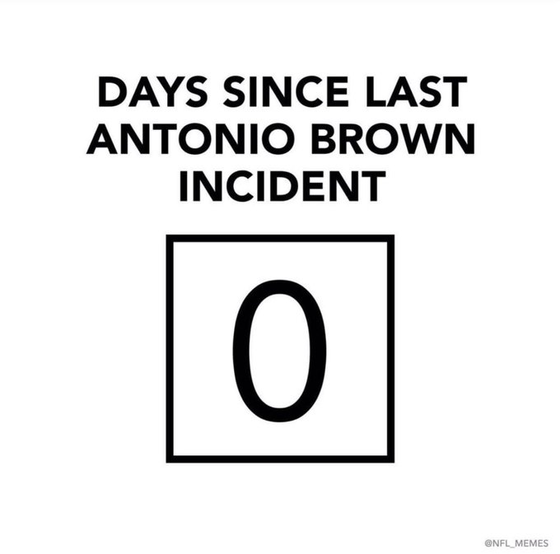

**(Per my brother Joe) NFL Christmas Wishes**

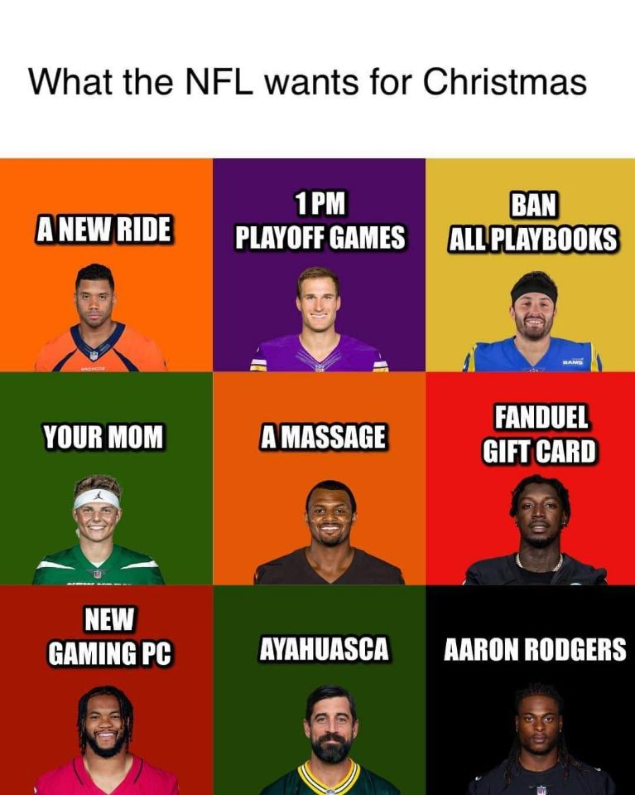

**(Per Meat) The “I didn’t know he was still in the league” Award**

Winner: Matt Breida

Runners-up: Nathan Peterman, Trevor Siemian, Kevin White

**(Per Joe) Best adult themed Nick Chubb Christmas gift**

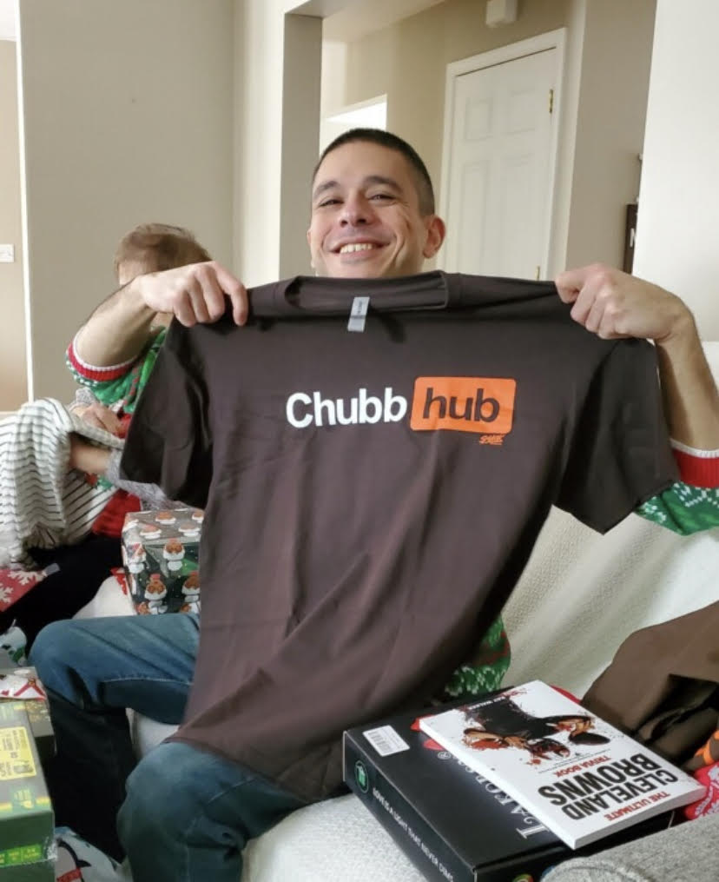

**Photo of George Pickens’ reaction to being traded to lifelong Steelers fan Jeremiah**

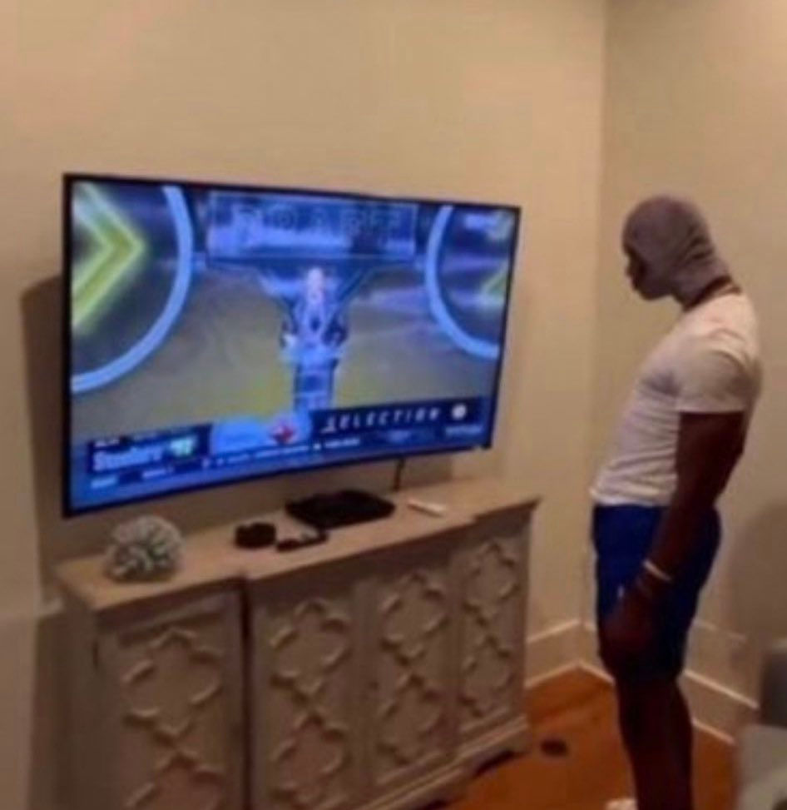

(Fun fact: Turns out this meme really is a [photo of George Pickens](https://fansided.com/2022/05/02/george-pickens-steelers-draft-video/), reacting to being drafted by Pittsburgh in the NFL draft)

**2022 Dodge Dynasty Playoff Results, available** [**here**](https://fantasy.espn.com/football/league/playoffs?leagueId=275479) **(Note there are SIX playoff teams)**

**Dodge Dynasty History (as always, available** [**here**](http://startdrafting.com/Draft/History)**)**

# **Perfect Lineups**

# **Next Year’s Draft Order**

Draft order for every round (excluding any 1st round comp picks)

1. Steve *
2. Jeremiah **
3. Jay
4. Jason
5. Twitch
6. Meat
7. Kerkel
8. Dave
9. Toot
10. World Champion George

* Steve's 7th round pick traded to George; Steve receives George's 12th round pick

** Jeremiah's 8th round pick traded to George; Jeremiah receives George's 10th round pick

# **Adjusted Total Points (used for Non-Playoff Draft Order)**

